**SVKM’S NMIMS**

**MUKESH PATEL SCHOOL OF TECHNOLOGY MANAGEMENT& ENGINEERING**

**(Campus Name)**

**Academic Year: 2022-2023**

# **Practical 2-First Come First Serve Scheduling algorithm**

|  |  |  |  |  |
| --- | --- | --- | --- | --- |
| Name Arjun Mehta | Roll_No K036 | SAP-ID  70102300018 | BATCH  K1 | DATE  10-01-25 |
|  |  |  |  |  |
|  |  |  |  |  |

Dear all,

Kindly complete the following task with your name in output file.

### **Example 1:-**

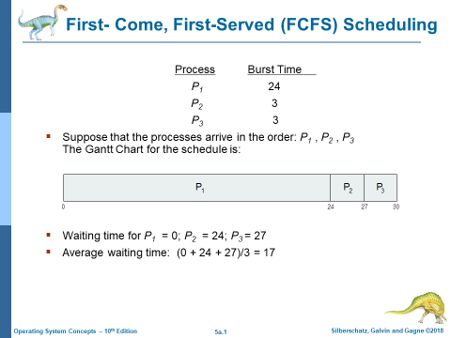

Example 2

.



Example 3

|  |  |  |
| --- | --- | --- |
| Process | Arrival time | Burst time |
| P1 | 0 | 5 |
| P2 | 1 | 6 |
| P3 | 2 | 7 |

Theoretical calculation:

Program:

# List of processes with (Process ID, Burst Time)

processes = [(1, 5), (2, 3), (3, 8), (4, 6)]

# Initialize waiting time and turnaround time lists

waiting_time = [0] * len(processes)

turnaround_time = [0] * len(processes)

# Calculate waiting time

for i in range(1, len(processes)):

waiting_time[i] = processes[i - 1][1] + waiting_time[i - 1]

# Calculate turnaround time

for i in range(len(processes)):

turnaround_time[i] = processes[i][1] + waiting_time[i]

# Print the results

print("Process | Waiting Time | Turnaround Time")

for i in range(len(processes)):

print(f"{processes[i][0]} | {waiting_time[i]} | {turnaround_time[i]}")

**Example 2:**

Result screenshot:

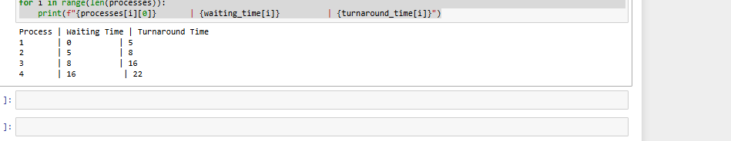

## **Conclusion:-**

Write your observation about FCFS algorithm. how the waiting time can be reduced in FCFS algorithm? Write your idea.

In conclusion, the FCFS scheduling algorithm is one of the basic scheduling algorithms used in operating systems. It schedules the processes in the order in which they arrive in the ready queue, which is fair to all the processes.

References:

1. <https://www.geeksforgeeks.org/preemptive-and-non-preemptive-scheduling/>
2. <https://www.guru99.com/fcfs-scheduling.html>
3. <https://www.javatpoint.com/os-fcfs-scheduling>